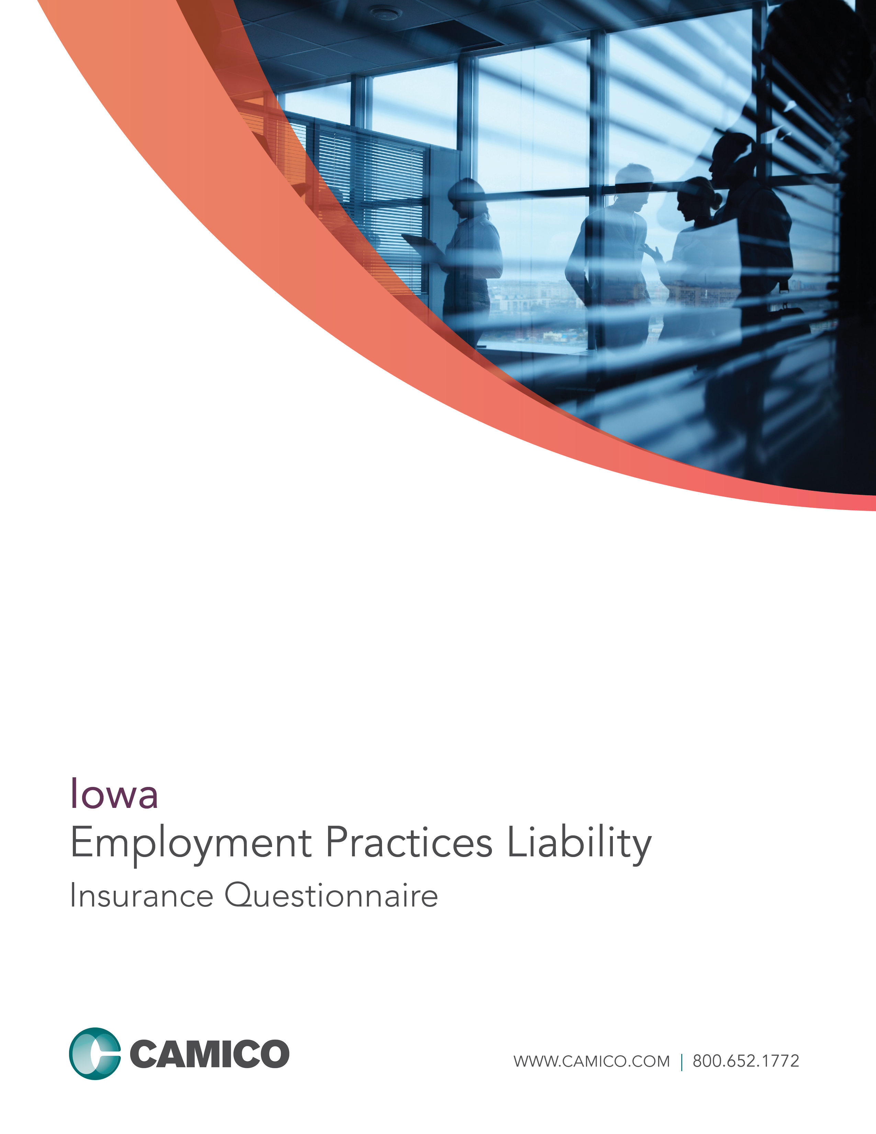

EMPLOYMENT PRACTICES LIABILITY INSURANCE QUESTIONNAIRE

This is an application for a “Claims Made and Reported” policy. The policy applies only to employment practices claims first made against the Insured and reported to the Company while the policy is in force and for employment practices occurring after the prior acts date. The limit of liability available to pay damages or settlements shall be reduced by amounts incurred as “Claim Expenses,” including fees and expenses incurred in the investigation, adjustment, and defense of a claim or multiple claims. The policy will be issued in reliance upon the statements in the application. Therefore, it is important that all questions be answered accurately.
Please follow the steps listed below to complete your questionnaire for CAMICO coverage:
- Complete all sections of the questionnaire, answering all questions completely. If any question, or part thereof, does not apply, print “NA” in the space provided - leave no blanks. Failure to answer all questions will delay our ability to underwrite this questionnaire, which may result in a gap in your coverage.
- Sign on page 3 and make a copy of the completed questionnaire for your records.
- Return the completed questionnaire (see below for mailing address).

Part I: Firm Information

- Firm Name:
- Firm Address:
Street Address City County State Zip
- Telephone:
- Fax:
5. Primary contact for EPL insurance: E-mail:
6. Please list the total number of employees: PLEASE DO NOT INCLUDE EQUITY PARTNERS IN THE FIRM
7. Within the last five years, has the Firm or any individual proposed for this insurance:
  - Received any employment-related inquiry, complaint or charge from any municipal, state, or federal regulatory authority or any other governmental entity? Yes No
  - Had any employment-related claim, suit, grievance, or demand brought against them? Yes No
If “Yes”, please attach separate sheet with date, names of parties, description, amount demanded and amount paid or reserved.
8. Are you aware of any facts, incidents or circumstances that may result in a claim or claims being made against you? Yes No
If “Yes”, please attach separate sheet providing details including names of parties.
9. Do you currently carry EPL insurance? Yes No
If “Yes”, please attach a copy of your EPL declarations page.

Part II: Employment Practices

10. Do you distribute an Employee Handbook to your employees? Yes No
a. If you distribute an Employee Handbook, do you require employees to acknowledge that they have received and understood it? Yes No
b. If you distribute an Employee Handbook, does it contain:
    - An employment-at-will statement? Not applicable due to our state law Yes No
    - A written equal employment opportunity statement? Yes No
    - A written sexual harassment and other harassment policies? Yes No
    - A written internal complaint procedure for discrimination and sexual harassment claims? Yes No
  - If you do not distribute an Employee Handbook, do you have written policies on all of the above that are distributed separately? Yes No
Specify any that are not:
11. Do you provide sexual harassment training to employees? Yes No
If “Yes,” provide the date of your Firms last sexual harassment training:
12. Do you use an employment application during your hiring process? Yes No
13. Do you post, in places conspicuous to all employees and applicants for employment, all notices required by law? Yes No
14. Do you have a documented process for handling all employee complaints? Yes No

Part III: Acknowledgement of No-Known Claims

The below authorized owner or partner declares that the following is understood. After inquiry of all stockholders, partners and employees, I am not currently aware of any employment practices, incident, circumstance, dispute or problem which could reasonably be expected to be the basis of a claim being made against the firm, its predecessors or any partner, officer or employee, by any current or former employee, contract worker or applicant, that has not been reported to CAMICO. I also am aware that the failure of any Insured to disclose such known facts, employment practices, incident, circumstance, dispute or problem here may entitle CAMICO to void the proposed policy in its entirety if CAMICO establishes that any Insured has misrepresented or concealed any information that is material to the risk and/or that contributed to a claim for which coverage is sought.

Part IV: Signature

The undersigned proprietor, authorized partner of the partnership, or authorized stockholder of the corporation represents that the following statements are understood and agreed to by the applicant:

By signing this application, the undersigned represents that he or she has made inquiries of all Firm members as appropriate and that all Firm members are bound by the representations made on this application, any supplemental application, and any supplemental data and documents provided.

Signing this application or tendering premium does not bind the applicant or the company to issue insurance coverage, but it is agreed that this application shall be the basis of the contract should a policy be produced.

After inquiry of all stockholders, partners and employees, the undersigned is not currently aware of any act, error, omission, incident, circumstance, dispute, fee dispute or employee problem, which could reasonably be expected to be the basis of a claim being made against the Firm, its predecessors or any partner, stockholder or employee, that has not been reported to another insurer. It is understood and agreed that any claim emanating from such knowledge or information shall be excluded from coverage under the proposed policy.

IMPORTANT: CAMICO intends to rely upon your answers to questions in this application and any attached supplements in reaching its decision to offer coverage and/or to offer coverage excluding any described activities. Inaccurate responses to inquiries may result in a loss of coverage for activities and/or a decision by CAMICO to rescind the entire policy. Your signature below acknowledges your understanding of this notice.

FRAUD WARNINGS – Residents of Alabama, Arkansas, Colorado, District of Columbia, Florida, Kansas, Kentucky, Maryland, New Jersey, New Mexico, Ohio, Oklahoma, Oregon, Pennsylvania, Rhode Island, Tennessee, Virginia, and West Virginia
Applicable in AL, AR, MD, NM, RI and WV: Any person who knowingly (or willfully)* presents a false or fraudulent claim for payment of a loss or benefit or knowingly (or willfully)* presents false information in an application for insurance is guilty of a crime and may be subject to fines and confinement in prison. *Applies in MD Only. Applicable in CO: It is unlawful to knowingly provide false, incomplete, or misleading facts or information to an insurance company for the purpose of defrauding or attempting to defraud the company. Penalties may include imprisonment, fines, denial of insurance and civil damages. Any insurance company or agent of an insurance company who knowingly provides false, incomplete, or misleading facts or information to a policyholder or claimant for the purpose of defrauding or attempting to defraud the policyholder or claimant with regard to a settlement or award payable from insurance proceeds shall be reported to the Colorado Division of Insurance within the Department of Regulatory Agencies. Applicable in DC: It is a crime to provide false or misleading information to an insurer for the purpose of defrauding the insurer or any other person. Penalties include imprisonment and/or fines. In addition, an insurer may deny insurance benefits if false information materially related to a claim was provided by the applicant. Applicable in FL and OK: Any person who knowingly and with intent to injure, defraud, or deceive any insurer files a statement of claim or an application containing any false, incomplete, or misleading information is guilty of a felony (of the third degree)*. *Applies to FL Only. Applicable in KS: Any person who, knowingly and with intent to defraud, presents, causes to be presented or prepares with knowledge or belief that it will be presented to or by an insurer, purported insurer, broker or any agent thereof, any written statement as part of, or in support of, an application for the issuance of, or the rating of an insurance policy for personal or commercial insurance, or a claim for payment or other benefit pursuant to an insurance policy for commercial or personal insurance which such person knows to contain materially false information concerning any fact material thereto, or conceals, for the purpose of misleading, information concerning any fact material thereto, commits a fraudulent insurance act, which is a crime and subjects such person to criminal and civil penalties. Applicable in KY, OH and PA: Any person who knowingly and with intent to defraud any insurance company or other person files an application for insurance or statement of claim containing any materially false information or conceals for the purpose of misleading, information concerning any fact material thereto commits a fraudulent insurance act, which is a crime and subjects such person to criminal and civil penalties. Applicable in TN and VA: It is a crime to knowingly provide false, incomplete or misleading information to an insurance company for the purpose of defrauding the company. Penalties include imprisonment, fines and denial of insurance benefits. Applicable in NJ: Any person who includes any false or misleading information on an application for an insurance policy is subject to criminal and civil penalties. Applicable in OR: Any person who knowingly and with intent to defraud or solicit another to defraud the insurer by submitting an application containing a false statement as to any material fact may be violating state law.

Name: (Please Print)
Signature: Date:
Position/Title:
Applicant/Firm:

Agent, broker or producer for this application for coverage:
Producer Name: (Please Print) Date:
Company:

Document Checklist

Mail or fax this form to the address below:
- Additional sheets with information as required in questions 7 and 8.
- A copy of your EPL insurance declarations page if you currently have coverage.

Sales Department Call: 1.800.652.1772
CAMICO Mutual Insurance Company E-mail: inquiry@camico.com
1800 Gateway Drive, Suite 200 Web: www.camico.com
San Mateo, CA 94404 Fax: 1.800.227.2090

