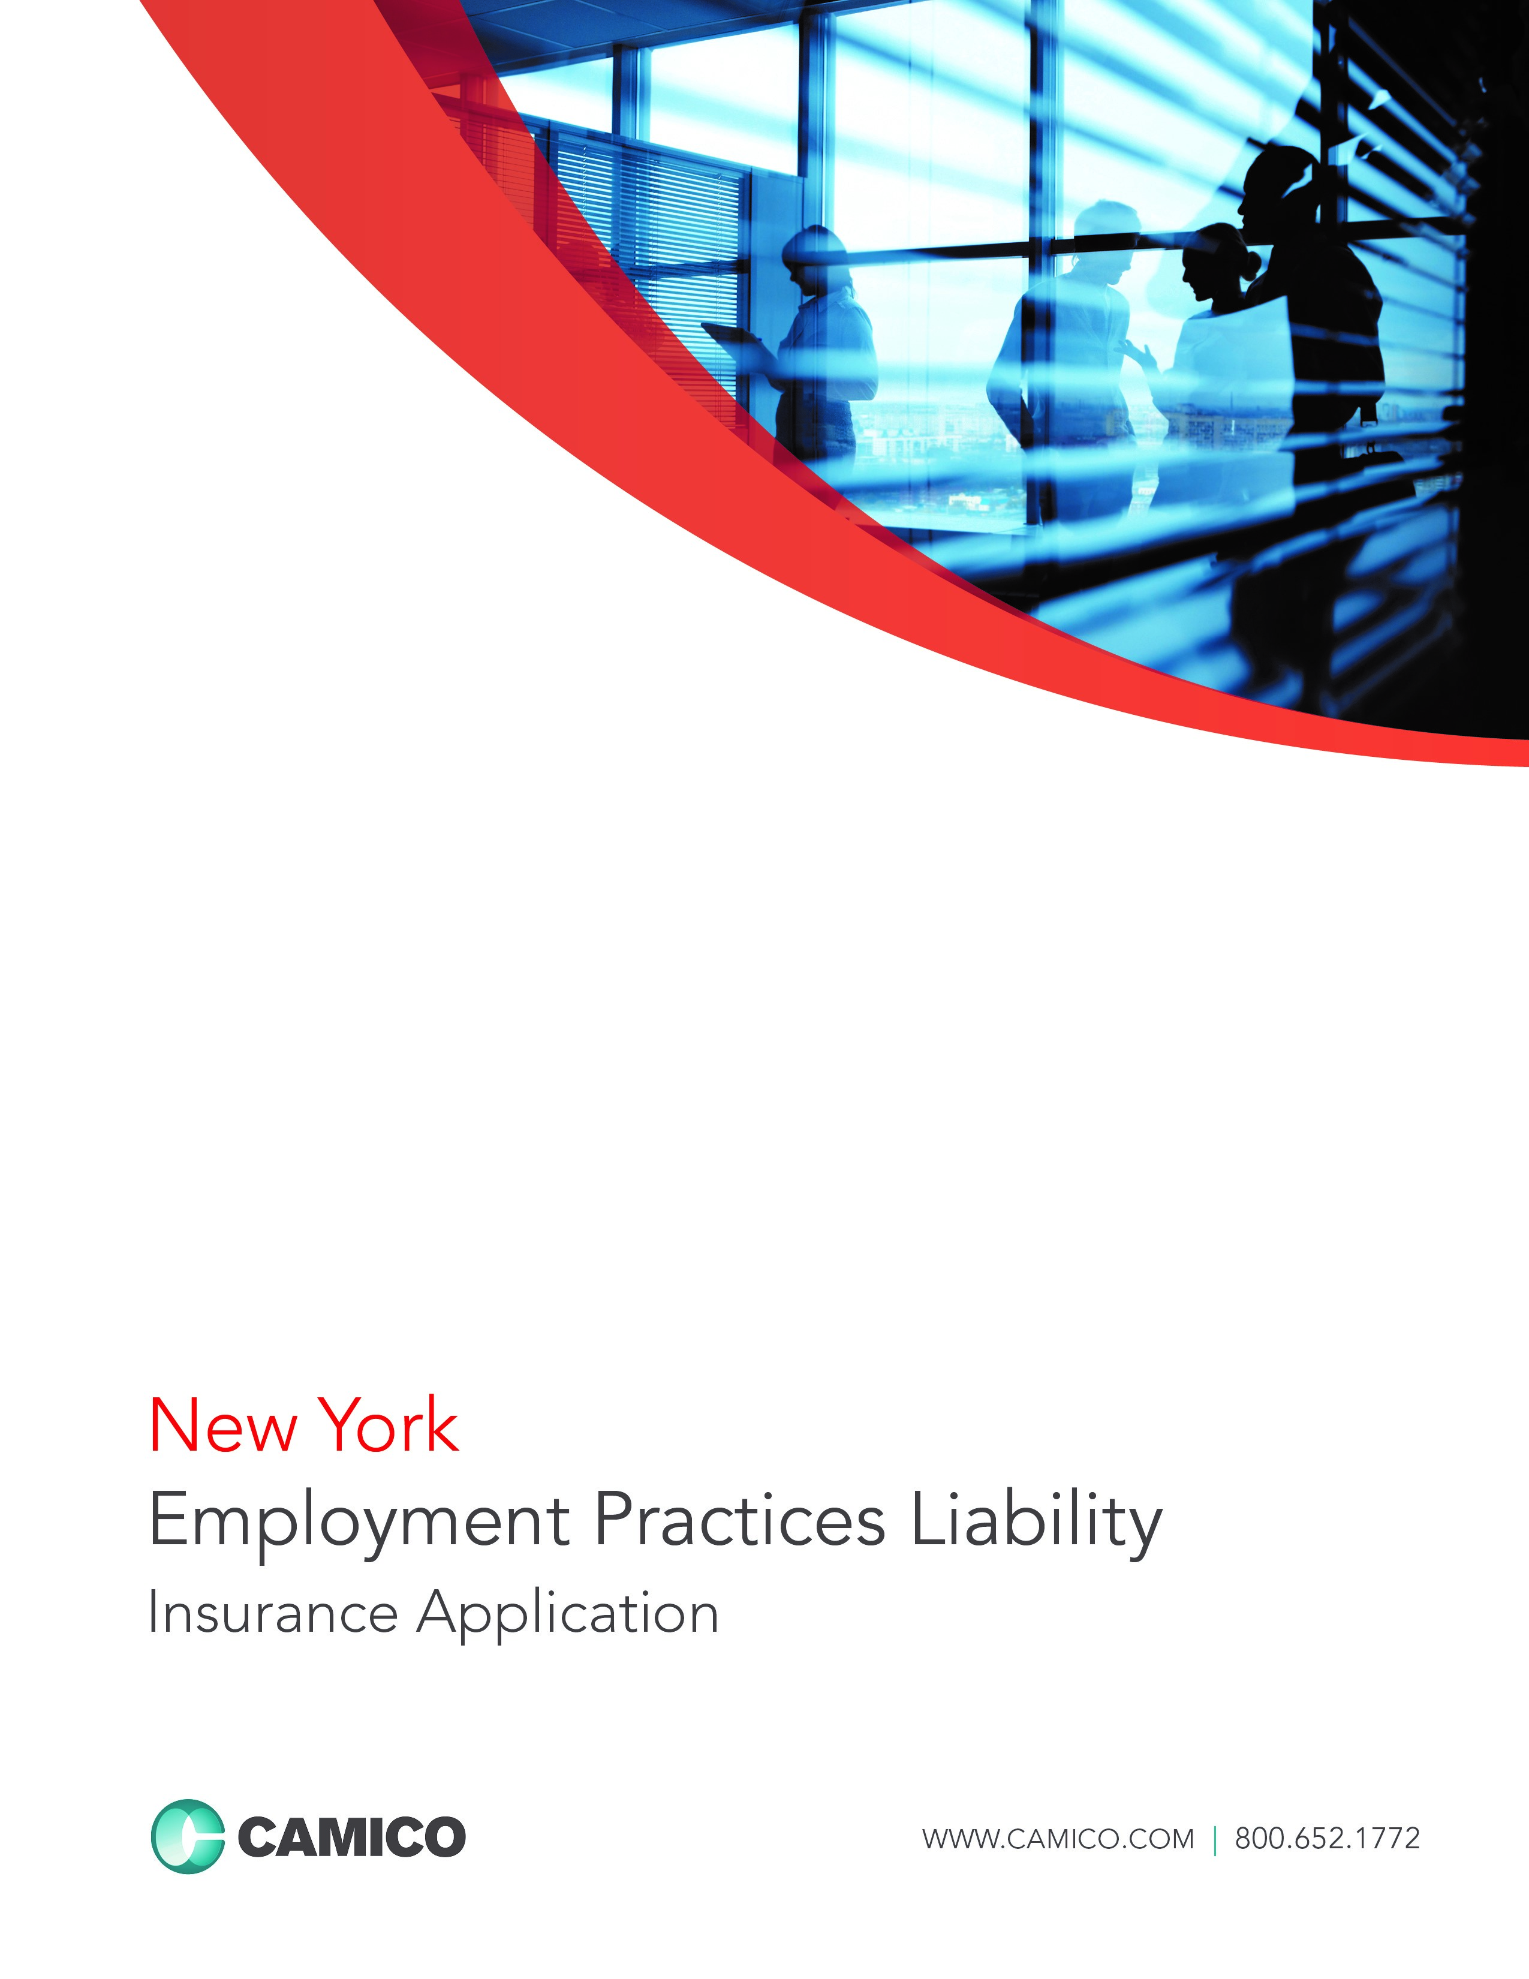
NOTICE: THESE POLICY FORMS AND THE APPLICABLE RATES ARE EXEMPT FROM THE FILING REQUIREMENTS OF THE NEW YORK STATE INSURANCE DEPARTMENT. HOWEVER, SUCH FORMS AND RATES MUST MEET THE MINIMUM STANDARDS OF THE NEW YORK INSURANCE LAW AND REGULATIONS.
THIS IS AN APPLICATION FOR A CLAIMS-MADE POLICY. THE POLICY PROVIDES NO COVERAGE FOR CLAIMS ARISING OUT OF EMPLOYMENT PRACTICES WHICH TOOK PLACE PRIOR TO THE RETROACTIVE DATE. THE POLICY COVERS ONLY CLAIMS ACTUALLY MADE AGAINST AN INSURED WHILE THE POLICY REMAINS IN EFFECT. ALL COVERAGE UNDER THE POLICY CEASES UPON THE TERMINATION OF THE POLICY EXCEPT FOR THE BASIC EXTENDED REPORTING PERIOD, OR UNLESS THE NAMED INSURED PURCHASES SUPPLEMENTAL EXTENDED REPORTING PERIOD. THE LIMITS OF LIABILITY AVAILABLE TO PAY DAMAGES OR SETTLEMENTS SHALL BE REDUCED BY AMOUNTS INCURRED AS CLAIM EXPENSES, INCLUDING FEES AND EXPENSES INCURRED IN THE INVESTIGATION, ADJUSTMENT, AND DEFENSE OF A CLAIM FOR LIMITS OF $100,000 OR GREATER. SUCH CLAIM EXPENSES SHALL ALSO BE APPLIED AGAINST THE DEDUCTIBLE BY THE AMOUNT OR PERCENTAGE STATED IN THE POLICY. PLEASE REFER TO THE POLICY FOR THE EXACT TERMS AND CONDITIONS CONCERNING THE COMPANY’S LIMITS OF LIABILITY.

Apply for a CAMICO Employment Practices Liability (EPL) Policy
This is an application for a “Claims-Made” policy. The Policy provides no coverage for Claims arising out of employment practices which took place prior to the Retroactive Date. The Policy covers only Claims actually made against an Insured while the Policy remains in effect. The limit of liability available to pay damages or settlements shall be reduced by amounts incurred as “Claim Expenses,” including fees and expenses incurred in the investigation, adjustment, and defense of a claim or multiple claims. The Policy will be issued in reliance upon the statements in the application. Therefore, it is important that all questions be answered accurately.
Please follow the steps listed below to complete your application for CAMICO coverage:
1. Review all definitions at the bottom of the page.
2. Please type or print clearly, and do not use pencil.
3. Complete Parts I through VII, answering all questions completely. If any question, or part thereof, does not apply, print “NA” in the space provided - leave no blanks. Failure to answer all questions will delay our ability to underwrite this application, which may result in a gap in your coverage.
4. Complete supplemental application(s) only when appropriate.
5. Sign on page 6 and make a copy of the completed application for your records.
6. Return the completed application (see page 6 for mailing address).
Common Phrases and Definitions
CLAIMS-MADE
The Policy is a claims-made policy. Except to such extent as may otherwise be provided herein, the coverage of the Policy is limited to employment practices liability for only those claims that are first made against the Insured while the Policy is in force. Please review the Policy carefully and discuss the coverage with your CAMICO representative.
FIRM
The term “Firm” means the entity listed in Part I, question 1 of this application and any individual owner (proprietor, stockholder, partner) and any individual employee of the entity listed in Part I, question 1 of this application.
PRIOR ACTS
Coverage for employment practices prior to inception of this Policy may be requested where the Firm has current employment practices liability coverage.
If this Policy is written with prior acts coverage it shall apply only to claims for damages as a result of employment practices which first take place on or after the prior acts (retroactive) date.
PART-TIME
Persons who work more than 32 hours per week or 1,600 hours per year, even if seasonal, are Full-time. Persons who work less than 32 hours per week or 1,600 hours per year are considered Part-time.

Part I: Firm Information
1. Firm Name:
2. Contact Person: 3. Requested Effective Date:
4. Title: 5. E-mail Address:
6. Primary Office Address:
Street Address City County State Zip
If your Firm operates from any other office location(s), please complete Part I, Question 6, of the EPL Insurance Supplement (E-1).
7. Telephone: 8. Fax: 9. Web Site:
10. Mailing Address:
(if different from #6) Street Address City County State Zip
11. Entity Type: Sole Proprietorship Partnership Corporation LLP LLC PC Other (list):
12. Date Firm Established (mm/dd/yyyy):
13. List Name(s) of all Partners/Owners.
Name | % Ownership | Title | Professional Organization Memberships | E-mail Address
Please use Part I, Question 13, of the EPL Insurance Supplement (E-1) if additional room is needed

Part II: Firm Profile
14. For the location listed above in Question 6, please list the total number of employees, workers and independent contractors, broken down by Full-Time employees, Part-Time employees, Contract Workers, Leased Workers and Independent Contractors, for each of the last three years (please refer to explanation of staff types on page 2):
If your Firm operates from any other office location(s), please complete Part II, Question 14, of the EPL Insurance Supplement (E-1).
PLEASE DO NOT INCLUDE PARTNERS IN THE FIRM
 | Current Year | Prior Year | 2 Years Ago
# of Full-Time Employees
# of Part-Time Employees
# of Contract Workers
# of Leased Workers
# of Independent Contractors
Total

Explanation of Staff Types
Full-Time Employee:
Defined as a person employed by the Named Insured for wages or salary or any non-equity partners of the firm. Employee does not include any Contract Worker, any Independent Contractor, any employee of an Independent Contractor, or any Leased Worker.
Part-Time Employee:
Defined as employees working less than 32 hours per week/1600 hours per year.
Contract Worker:
Defined as a natural person who contracts directly with the Named Insured to provide professional services on behalf of the Named Insured. For example, a seasonal tax worker performing services for the firm’s clients would be considered a Contract Worker.

Leased Worker:
Defined as a person leased to the Named Insured by a labor leasing firm under an agreement between the Named Insured and the labor leasing firm to perform duties related to the conduct of the Named Insured’s business. Leased Worker does not include a Contract Worker.

Independent Contractors:
Defined as independent contractors/per diem workers. For example, a non-employee individual working in a non-client related area, such as IT/telephone/data maintenance, would be considered an independent contractor.

15. If you wish to include coverage by endorsement for Independent Contractors, please indicate by
answering “Yes.” (See Question 14 for an explanation of what constitutes an Independent
Contractor) Yes No
Unless specifically amended by an endorsement, there is no coverage for any claims brought by Independent Contractors.
To obtain this endorsement, please complete Part II, Question 15, of the EPL Insurance Supplement (E-1). Please note
that an Independent Contractor can never be an “Insured” under your policy.

16. Breakdown of current Full-Time employees (excluding partners/owners) by their total cash compensation
(salary + bonus):
PLEASE DO NOT INCLUDE PARTNERS/OWNERS IN THE FIRM
Salary Ranges | # of Employees | % of Total Employees
$30,000 or less per year
$30,001 – $100,000 per year
Over $100,000 per year
Total |  | 100%

17. Based on your Firm’s fiscal year-end data, please provide the following gross revenue figures (accrual basis
income):
Next Fiscal Year  (projected) | Current Fiscal Year  (estimated) | Last Fiscal Year
$ | $ | $

18. a. Have you had any branch or office closings, consolidations, layoffs or staff reductions (greater
than 10% of the workforce), mergers or acquisitions within the past 24 months? Yes No
If “Yes,” please provide details under Part II, Question 18a, on the EPL Insurance Supplement (E-1).
b. Do you anticipate any of the above within the next 12 months? Yes No
If “Yes,” please provide details under Part II, Question 18b, on the EPL Insurance Supplement (E-1).

19. Involuntary Turnover: Total number of employer-initiated terminations of Full-time and Part-time employees.
Voluntary Turnover: Total number of Full-time and Part-time employees who initiated their own separations and
voluntarily terminated their employment.
DO NOT INCLUDE SEASONAL WORKERS, RETIREES, INDEPENDENT CONTRACTORS OR INTERNS IN VOLUNTARY TURNOVER COUNT.

 | Involuntary Turnover: | Voluntary Turnover:
Current Year
Previous Year
2 Years Ago

Part III: Loss History

20. Within the last five years, has the company or any individual proposed for this insurance:
a. received any employment-related inquiry, complaint or charge from any municipal, state, or
federal regulatory authority or any other governmental entity? Yes No
b. had a claim, suit, grievance, or demand brought against them? Yes No
If “Yes,” to either a and/or b, please provide details under Part III, Question 20, on the EPL Insurance Supplement (E-1).
21. Are you aware of any facts, incidents, or circumstances that may result in a claim(s) being made
against you? Yes No
If “Yes,” please provide details under Part III, Question 21, on the EPL Insurance Supplement (E-1).

THE APPLICANT UNDERSTANDS AND AGREES THAT IF ANY FACTS, INCIDENTS, OR CIRCUMSTANCES EXIST WHICH MAY REASONABLY GIVE RISE TO A CLAIM UNDER THIS PROPOSED POLICY, THEN ANY CLAIMS ARISING FROM SUCH FACTS, INCIDENTS, OR CIRCUMSTANCES ARE EXCLUDED FROM COVERAGE THEREUNDER. FAILURE TO DISCLOSE SUCH KNOWN FACTS, INCIDENTS OR CIRCUMSTANCES HERE WILL VOID THE PROPOSED POLICY IN ITS ENTIRETY.

Part IV: Insurance Information
22. Do you currently carry Employment Practices Liability insurance? Yes No
If “Yes,” please attach a copy of your current declarations page and provide:
Carrier: | Limit (per claim/aggregate):
Policy Term: From: To: | Retroactive Date:
Deductible: | Co-Insurance Amount, if any:
Premium:

23. Has any insurer ever canceled or non-renewed this type of coverage? Yes No
If “Yes,” please provide details under Part IV, Question 23, on the EPL Insurance Supplement (E-1).

24. Requested limit of liability and deductible (check all options you wish quoted):
Limit of Liability:  Per Claim / Policy Aggregate |  |  | Deductible
 | $100,000 / $100,000 |  |  | $5,000
 | $250,000 / $250,000 |  |  | $10,000
 | $500,000 / $500,000 |  |  | $15,000
 | $500,000 / $1,000,000 |  |  | $20,000
 | $1,000,000 / $1,000,000 |  |  | $25,000
 | $1,000,000 / $2,000,000

25. Do you currently carry PROFESSIONAL LIABILITY INSURANCE? Yes No
If “Yes,” Carrier: Expiration Date:
Limit of Liability:
Part V: Risk Management Practices
26. Do you make use of any of the following tests to screen employment applicants, to promote employees,
or for the purpose of continuing employment?
a. Psychological or personality tests? Yes No
b. Drug or alcohol tests? Yes No
c. Pre-employment offer medical tests? Yes No
If “Yes,” please provide details under Part V, Question 26, on EPL Insurance Supplement (E-1).

27. a. Have all your employment-related policies and procedures been reviewed and approved by outside
counsel? Yes No If “Yes,” when?

b. Have all recommendations from that review been implemented? Yes No
If “No,” please explain or provide time frame for implementation under Part V, Question 27b, on the EPL Insurance Supplement (E-1).

28. a. Who is responsible for the Human Resources or Personnel functions?
Name: Title: E-Mail:
b. Is this contact the person to whom all employment related incidents are reported? Yes No
If “No,” to whom are these incidents reported?
c. Do you require that all employment terminations be reviewed by personnel having Human Resource
responsibility? Yes No

29. Do you distribute an Employee Handbook to your employees? Yes No
If “Yes,”
a. Do you require employees to acknowledge that they have received and understood the Handbook? Yes No
b. Does it contain:
i. an employment-at-will statement? Not applicable due to our State law Yes No
ii. a written equal employment opportunity statement? Yes No
iii. a written sexual harassment and other harassment policies? Yes No
iv. a written internal complaint procedure for discrimination and sexual harassment claims? Yes No
If “No,”
Do you have written policies on any of the above that are distributed separately? Yes No
Please specify which policies are distributed separately:

30. Do you provide training to your employees, including management, on any of the following employment
practice topics?
a. Sexual Harassment, Yes No
b. Discrimination, Yes No
c. Americans with Disabilities Act, Yes No
d. Family Medical Leave Act, Yes No
e. Reporting Incidents of Complaints. Yes No

31. Do you use an employment application during your hiring process? Yes No
If “Yes,” does it contain:
a. an employment-at-will statement? Not applicable due to our State laws Yes No
b. authorization to check references and criminal conviction records? Yes No
c. the applicant’s signature attesting that all representations are true? Yes No
d. an equal employment opportunity statement? Yes No

32. Management/Supervisor Training
a. Do you have a progressive disciplinary program? Yes No
If “Yes,” has it been distributed to supervisors in writing? Yes No
b. Do you post, in places conspicuous to all employees and applicants for employment, all notices
required by law? Yes No
c. When requested by employees, do you distribute information as required by federal law regarding
the Family Medical Leave Act? Yes No
d. Have you informed supervisory personnel, in writing, of their responsibility to provide
you with prompt notice of any claims, incidents or allegations? Yes No
e. Do you keep supervisors/management continually informed on any changes in employment practices? Yes No

33. Do employees have a venue for reporting any serious concerns relating to incorrect financial
reporting, and/or unethical or illegal conduct concerning the Firm? Yes No
If “Yes,” are these employees protected from any possible retaliation when they do report such activities? Yes No

34. Does the Firm have a documented process for handling all employee complaints? Yes No

35. Do all employees receive a written performance evaluation? Yes No
If “Yes,” how often?

36. Does the Firm offer Medical, Dental and 401(k) benefits to each employee? Yes No

Part VI: Additional Information
Please attach each of the following, if they exist. If they do not exist, please explain under Part VI on the EPL Insurance Supplement (E-1).

Your employee handbook
- Employment application form(s)
- Equal employment opportunity policy
- Discrimination and sexual harassment policy
- Separation agreement form

Part VII: Signature
The undersigned proprietor, authorized partner of the partnership, authorized, stockholder of the corporation, or authorized individual responsible for the human resources function represents to the best of his or her belief and knowledge, after reasonable inquiry, including inquiry of all stockholders, partners and employees and due diligence, the statements set forth in this application and any supplements thereto are true and correct.
The undersigned further declares that any claim, incident or event taking place prior to the effective date of the insurance applied for which may render inaccurate, untrue, or incomplete any statement made will immediately be reported in writing to the insurer. As a result, the insured may withdraw or modify any outstanding quotations and/or authorization or agreement to bind the insurance.

The signing of this application does not bind the undersigned to purchase the insurance, nor does the review of this application bind the insurance company to issue a policy.

The firm understands and agrees this application and any supplements thereto shall be incorporated into any policy that may be issued and the underwriters are relying on the truth of the statements set forth herein in making a determination to issue any policy.

The undersigned individual represents that he or she is duly authorized and empowered to make this application, including this representation, on behalf of the firm or any individual who may seek coverage under any binder or insurance policy issued in reliance hereon.

Name: (Please Print)
Signature: ________________________________________ Date:
Position/Title:
Applicant/Firm:

Thank you for applying for CAMICO coverage. Please send completed application and appropriate supplemental forms to:

Sales Department Call: 1.800.652.1772
CAMICO Mutual Insurance Company E-mail: inquiry@camico.com
45 Broadway, 16th Floor Web: www.camico.com
New York, NY 10006-3792 Fax: 1.800.496.9910

WARNING – NEW YORK RESIDENTS ONLY: Any person who knowingly and with intent to defraud any insurance company or other person files an application for insurance or statement of claim containing any materially false information, or conceals for the purpose of misleading, information concerning any fact material thereto, commits a fraudulent insurance act, which is a crime, and shall also be subject to a civil penalty not to exceed five thousand dollars and the stated value of the claim for each such violation.



(A Mutual Insurance Company)

NOTICE TO POLICYHOLDER – NEW YORK

DISCLOSURE NOTICE PURSUANT TO NEW YORK INSURANCE DEPARTMENT REGULATION 107

100% CLAIMS EXPENSE OFFSET LIMIT OF LIABILITY AND DEDUCTIBLE

This signed statement must be attached to, and made a part of, your policy.

Your signature on this statement acknowledges that you are aware, understand and agree that:

- The Limit of Liability provided by this Policy shall be reduced and may be completely exhausted by Claim Expenses; and

- To the extent that the Limit of Liability is exceeded, the Named Insured shall be liable for Claim Expenses and for the amount of any judgment or settlement; and

- Claim Expenses that are incurred shall be applied first against the Deductible up to 100% of the amount of the Deductible, and then against the applicable Limit of Liability.

Named Insured:

By:
Signature of a Principal or Partner

Name/Title:
Print Name and Title

Date:

EP-3025-A (08/07)
Classification Code: 2-14061

